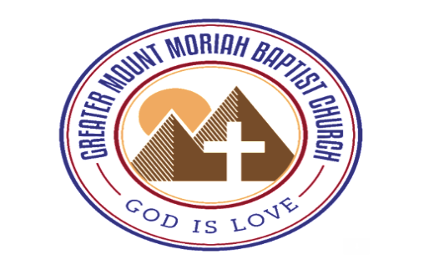
FREE FOOD AND CLOTHING GIVE AWAY
Free Food and Clothing
Distribution
Saturday, March 25, 2023
^{10 AM – 12 PM}
24 E. 14 th St., Linden NJ 07036
^{info@gmmbc.net|908-862-7766}

